**MODULE 1-4**

**1.** Install VirtualBox or VMware. Set up a virtual machine with any Linux distribution (preferably Kali Linux).

* **Screenshot Submission:** Screenshot of VirtualBox/VMware with the virtual machine running.

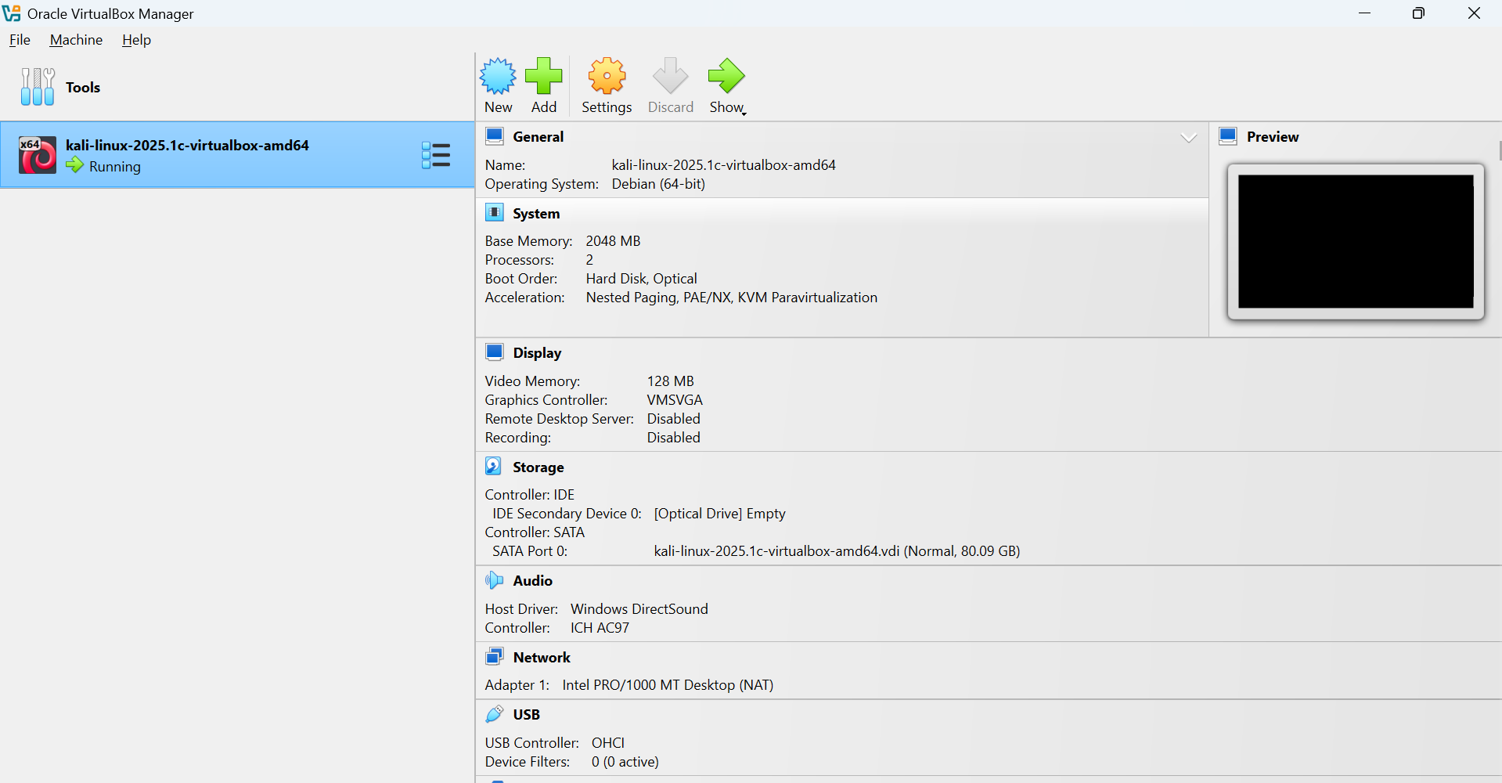

**2.**  Install Kali Linux in your virtual machine and update it..

* **Screenshot Submission:** Screenshot of the terminal showing the completion of the update.

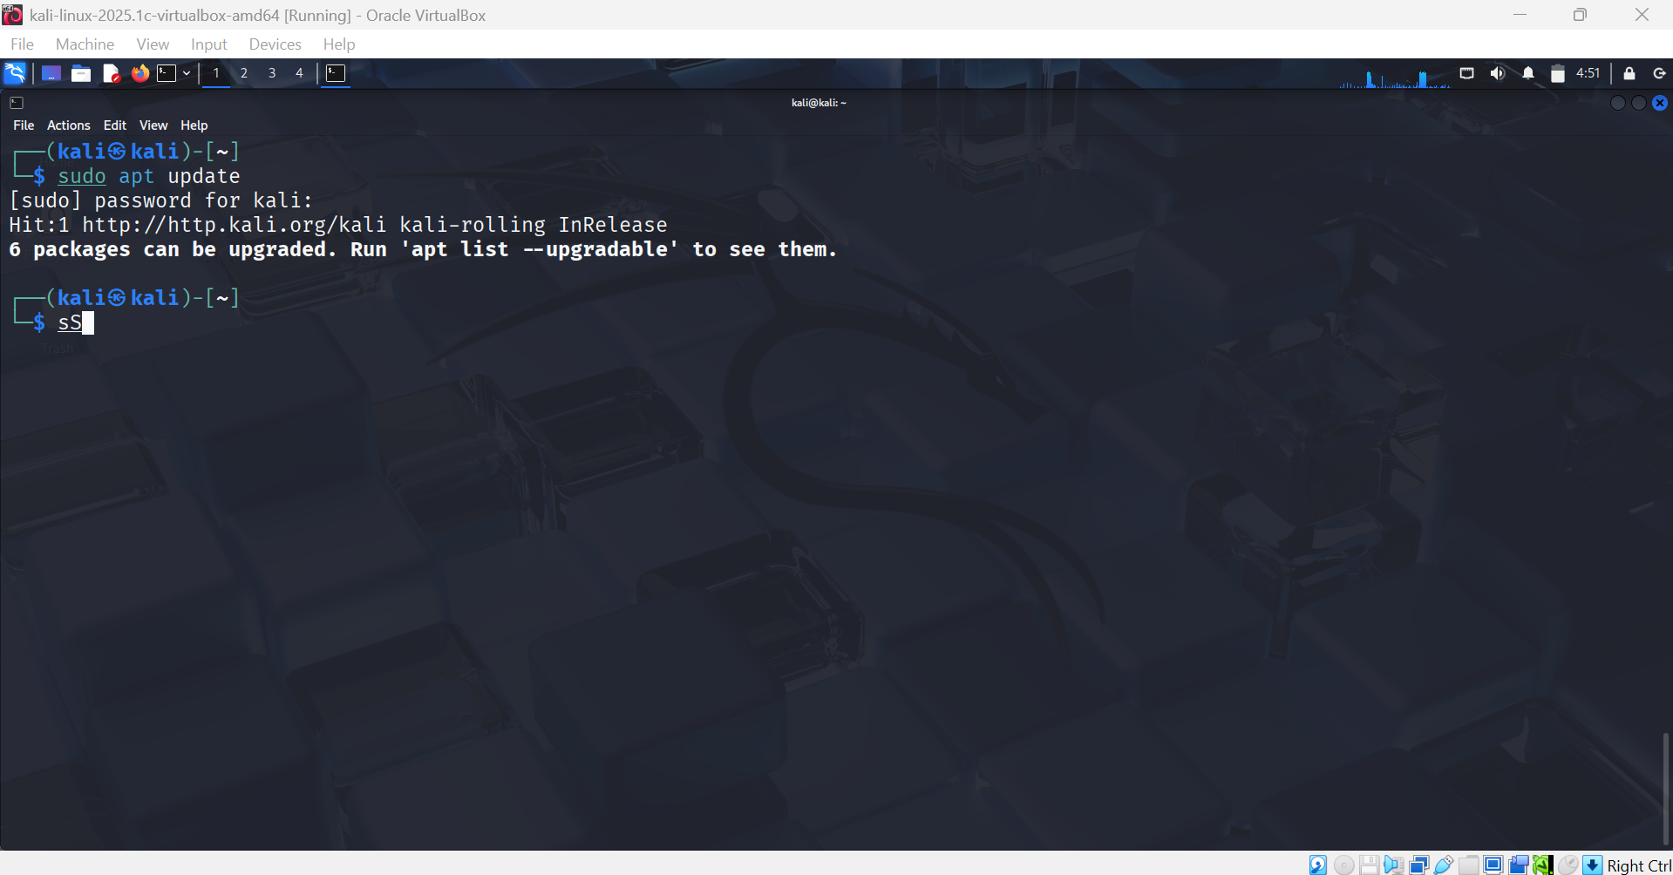

**3.** Explore the applications menu in Kali Linux. List 5 tools and their purpose.

**Screenshot Submission:** Screenshot of the applications menu.

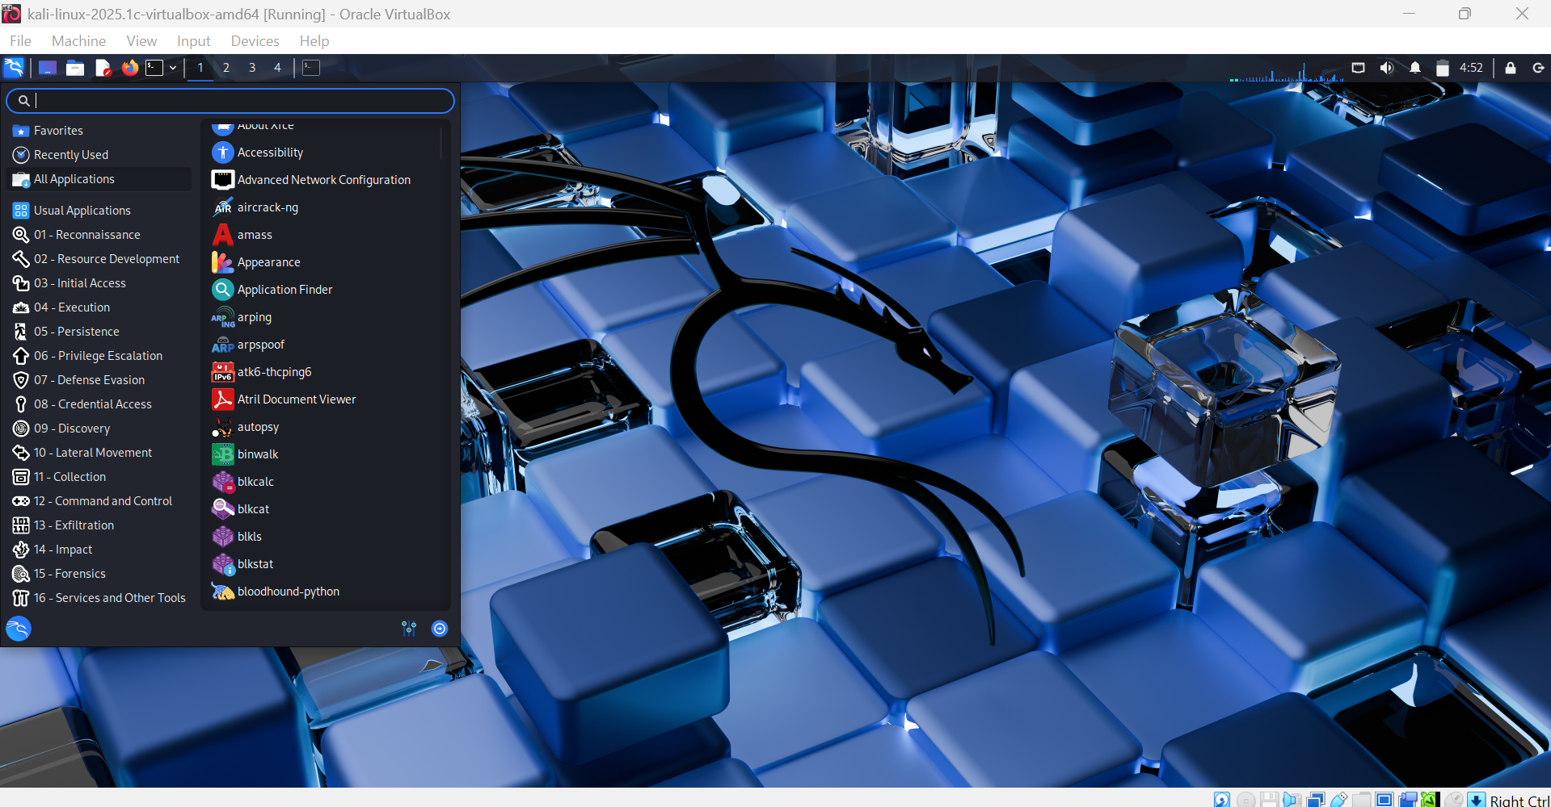

**4.** Execute the following Linux commands:

* Find command
* Ping command
* Traceroute command
* Whoami command
* Ps command
* **Screenshot Submission:** Screenshot of terminal output for each command.

1 – Find Command

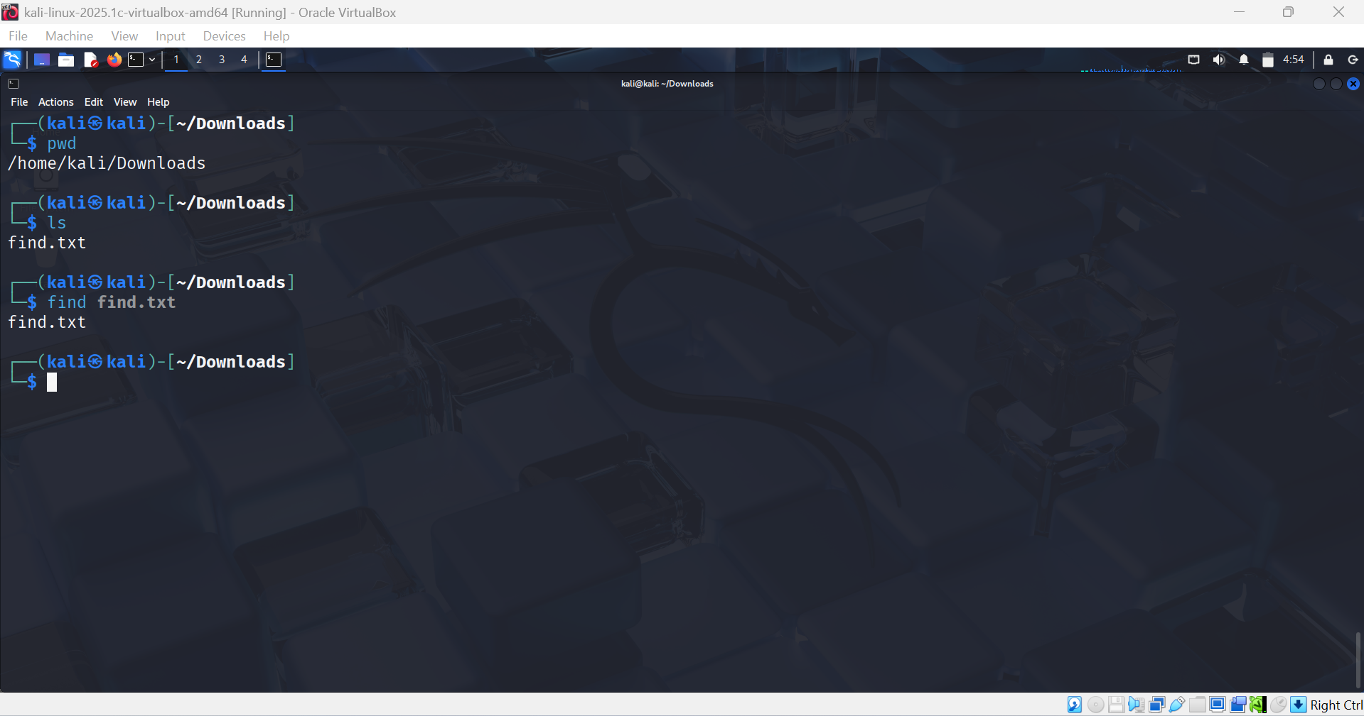

2 - Ping command:-

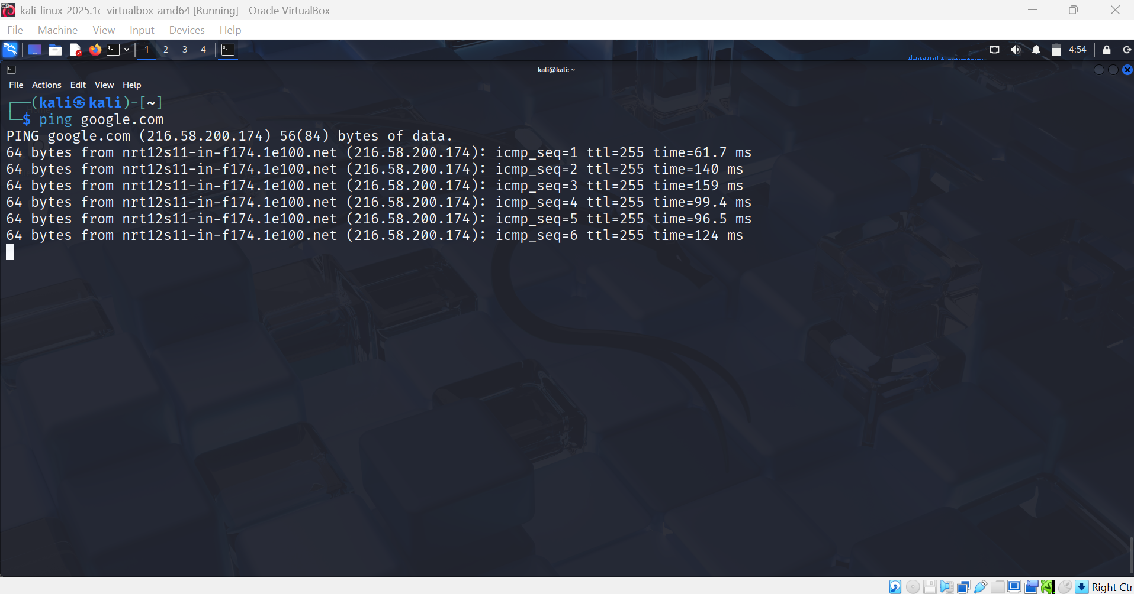

1. - Traceroute command

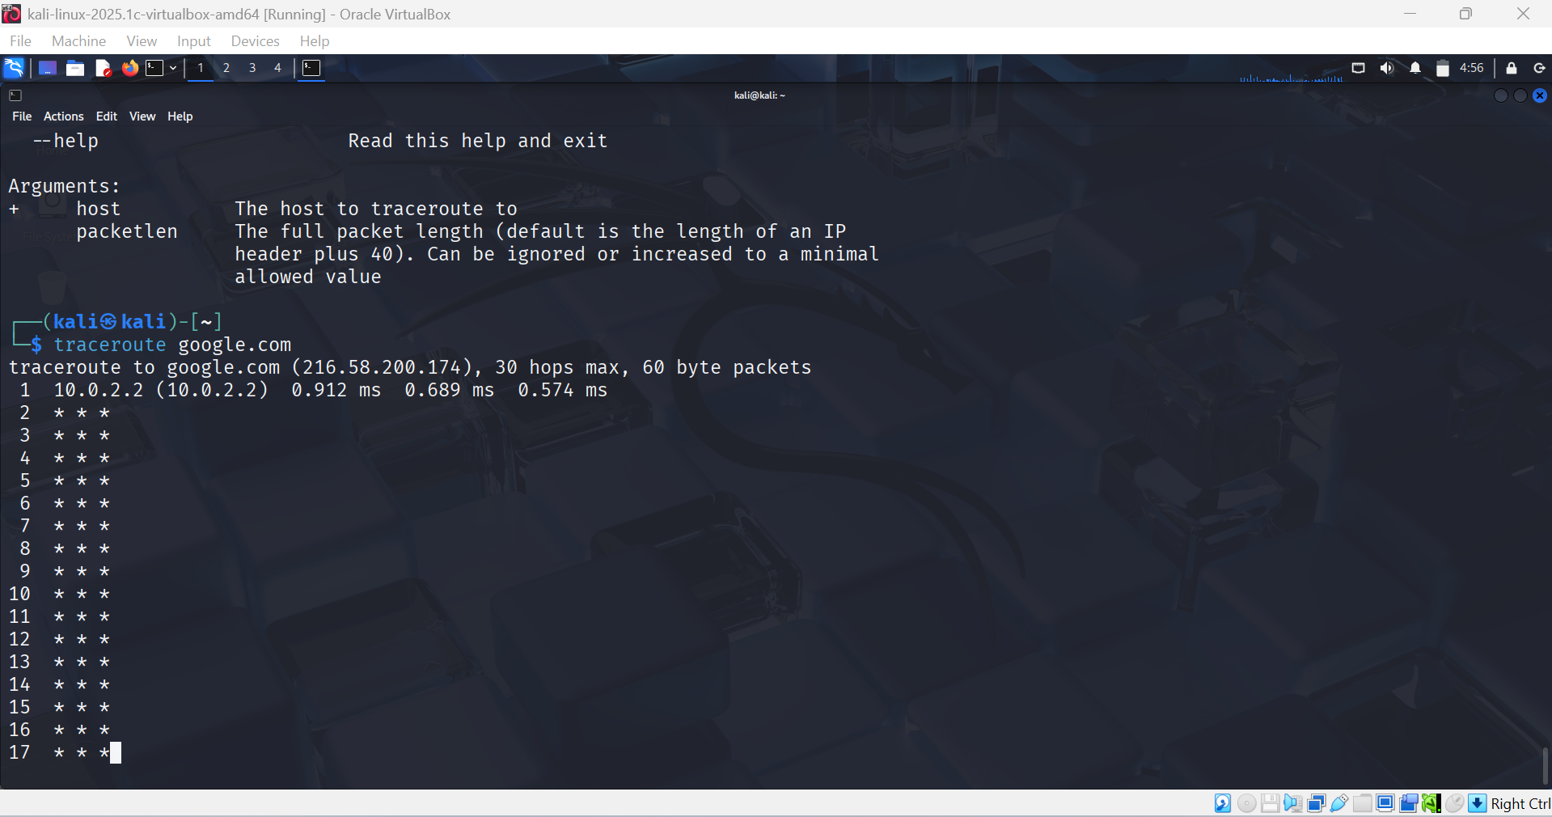

4 - Whoami command

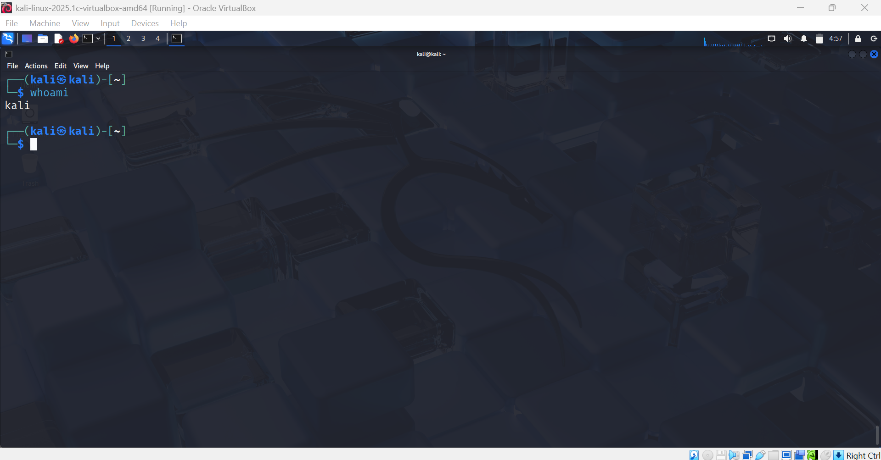

5 - Ps command

